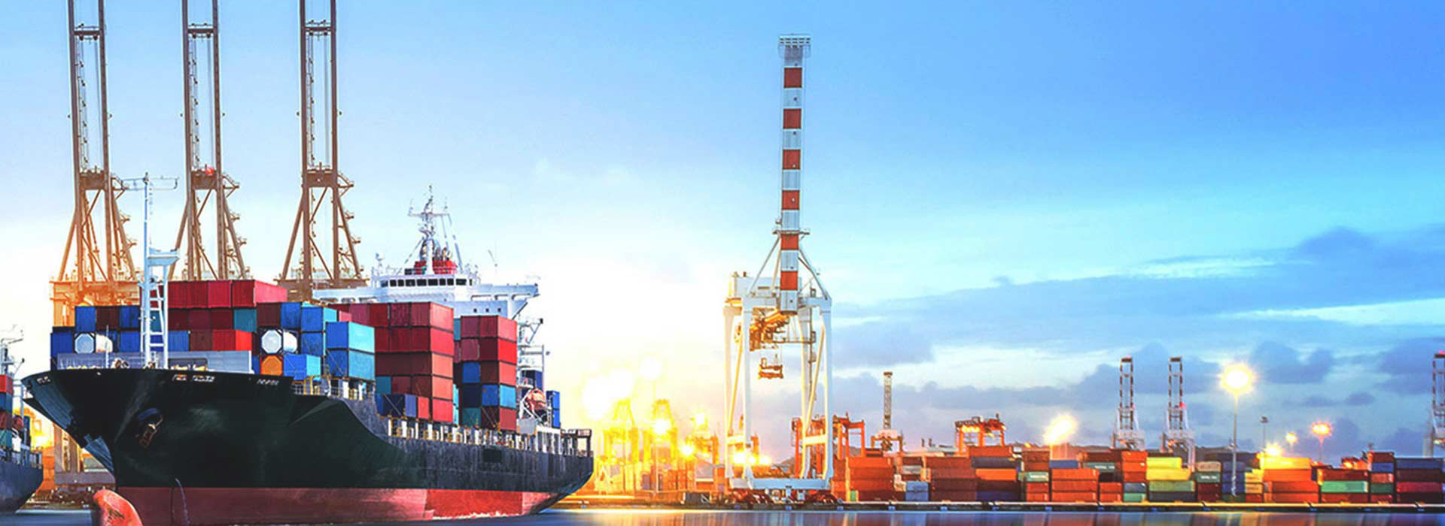
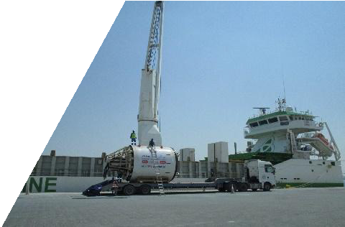
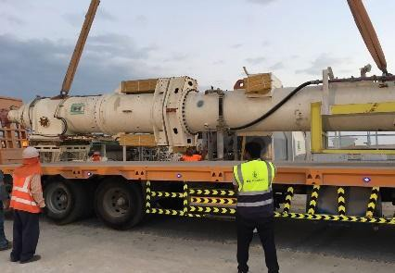
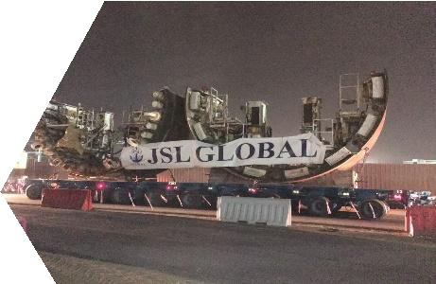
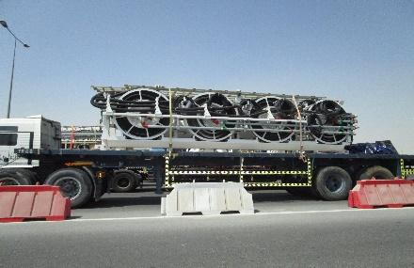
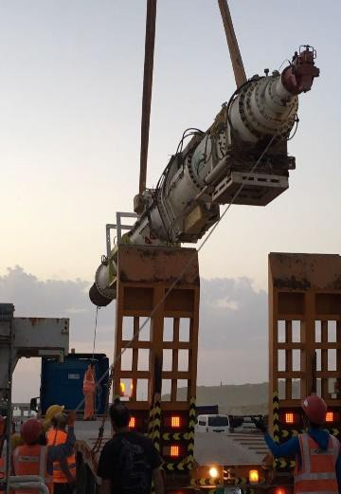

2012-2022 Project/Contracts

JSL Global WLL
Aff. Of Jassim Custom Clearance & Freight Co. Tel: +974 4485 0653 Fax: +974 4413 1529
Email : sales@jsl-global.net Website: www.jsl-global.net
JSL GLOBAL WLL - QATAR

SPECIALISE IN
PROJECT CARGO HANDLING

QATAR | OMAN | DUBAI | INDIA Page : 01

Introduction

Project Logistics requires specialized experience, commitment and ﬂexibility to execute difﬁcult cargo movements. JSL’s global network, Expert Team and solid track of Jassim Group provide the skills and strength that guarantees safe and timely delivery within Qatar, Middle East and Globally.

JSL operates in wide variety of sectors which have project logistics needs, including Government Project like Lusail City (Qatar), New Doha Port, Civil Aviation Authority, New Doha International Airport (NDIA), FIFA Stadium, Kahrama (Qatar Water Electricity Board), NFE – Nort Field expansion O&G and other oil & gas, mining, construction, power & energy and military and aid cargo.

JSL Team has experience of handling heavy project cargo, such as transformers, Cryogenic tanks, cable drums, generators, heat exchangers, cold box, heavy construction equipment or similar equipment.

JSL Team has experience of handling heavy project cargo, such as transformers, Cryogenic tanks, cable drums, generators, heat exchangers, cold box, heavy construction equipment or similar equipment.

Following report would brief the major projects which JSL Global has covered within the past few years in Qatar.

Project Name | Year | Client Name | Description/Scope of work | Approx Value of Freight/Tr ansport | Volume (CBM/FT/ Metric Tone) – Description of Shipping
Civil Defence | 2011-  2013 | Tom Otterson  USA | Scuplture movement for Hamad International Airport project | USD 172,000 | @50,000KG air freight from Chicago to DOH airport
Caltex Qatar | 2012-  2014 | Dow Chemicals/US Milatary | ISO tank movement | USD 85,720 | @82 ISO Tank from USA to Doha Port & delivery to Mesaieed
Mud Tank  Export | 2013 | Nakilat- NKOM | Ras Laffan plant to  Saipem plant in Al Khobar Transportation & Qatar local custo brokerage | USD  220,000 | 18 Low bed trailers + 6 Flat bed trailer shipment moved on single convoy (Tempoary import in KSA)
Mud Tank  Export | 2013 | Nakilat- NKOM | Ras Laffan plant  to Saipem Fujjairah Transportation & Qatar local clearance/ QASCO coordination & Chamber | USD  151,000 | 12 Low bed trailers + 8 Flat bed trailer shipment moved on single convoy (Tempoary import in KSA)
Ashghal/HIA & Hamad Port | 2013-  2017 | DYK USA | FR container & RORO vessel handling & local clearance/ transportation | USD  118,000 | Handled import-export & temporary importation for water tanks/material. @135+ container freight  /transportation
Metro Project | 2015 | Petroserv | Doha port clearance & transport/delivery to client site. (Cargo Steel plates) | USD  83,000 | 3662CBM / 120-180  Trucks – Flat bed &  Low bed trailers
Local | 2015-  2017 | Almana & Partners/ Unilever | 1200+ pallet storage on monthly basis | USD  870,000
MOQ Pipes | 2016 | Mearsk Oil Qatar | Doha port clearance & transport/delivery to client site. | USD  50,000 | 80+ trucks ex Hamad  port to Ras Laffan
IDRIS MTS 02 | 2016 | Herrenknecht AG/  Hoctief Qatar | TBM import from Germany to Hamad Port | USD  320,000 | 01 TBM/2800CBM /  48 Trailers

Project Name | Year | Client Name | Description/Scope of work | Approx Value of Freight/Tr ansport | Volume (CBM/FT/ Metric Tone) – Description of Shipping
IDRIS MTS01 | 2016 | BOUYGUES  Qatar | Several import-export custom clearance/ temporary importation permit/Freight ex Europe/china to  Doha & vice versa | USD  625,000 | Several jobs. @180+ container clearance at Hamad port & transportation.  07x40’FR export from Hamad Port. 33x40’ container import from China to Doha (Pipes)
IDRIS MTS 01  & 03 | 2016-  2017 | Herrenknecht AG/ | Micro TBM import from Germany to Hamad Port | USD  250,000 | 02 Micro TBMs/ 2200CBM/72 Trucks
 |  | Bouygues Qatar
Qatar Gas Tote Tanks | 2016-  2017 | Salam  Petroleum | Chemical tanks  export | USD  38,000 | Local Qasco coordination, Export clearance, FR containers to load 09 Tanks, Lashing & transportation to Europe
Local | 2016-  2017 | Carrefour Qatar | 04 Refer Trucks on annual rental basis | USD  120,000
Red Line Metro (South) | 2017 | Herrenknecht AG/ QDVC | TBM export  from Hamad Port  to Germany | USD  800,000 | 05 TBMs/ 15,000  CBM / @170+ Trailers
IDRIS MITS 02 | 2017 | Herrenknecht/  Hoctief | TBM export  from Germany to  Hamad Port | USD  450,000 | 01 TBM/2800CBM /  48 Trailers
Ashghal | 2017 | Hassensco Co Qatar | RT880E Groove  Crane from Canada to Hamad Port –delivery to client site | USD  58,000 | Bolton,Canada to Baltimore, USA transportation & RORO vessel Ex Baltimore to Hamad Port
Local | 2017 | ALYSJ JV-  Goldline Metro | 02 Tunnel Boring  Machine Export | USD  250,000 | 6000CBM/1660MT  cargo handled Ex work basis Qatar to Germany
Local | 2017 | MTH Qatar | 11 Construction  equipment + 27 container single lot | USD  206,000 | Al Khor – Hamad  Port- Male Port
Local | 2017 | Salam Petroleum (Emerson) | 14 meter x 3.6 meter x 3.6 meter  / 40 Modules | USD  329,000 | Hamad Port to NPP Site  (Shipment from Croatia)

Project Name | Year | Client Name | Description/Scope of work | Approx Value of Freight/Tr ansport | Volume (CBM/FT/ Metric Tone) – Description of Shipping
Local | 2017 | China Harbour | 5 Excavators | USD  22,000 | Ex work shipment from Site – Hamad Port- Malaysia
Local | 2017 | Idris MTS02 – Hoctief & Strabag | 04 Gantry Cranes | USD  357,000 | Handled packing/stufﬁng/loadin g of cargo in  20x40’OT + 4x40’FR
 |  |  |  |  | + RORO movement @520CBM cargo – 27 meter long x 08Nos Girders ex client site to Hamad Port & DAP to Germany.
Local | 2017 | Kelvion Engineering/ How United Qatar | 06x40’OT (OOG) + 2x40’FR (OOG) | USD  77,000 | Handled Ex Dubai to Qatar via Oman. (during blockade)
Local | 2017 | Qatar Lubricant–  QALCO | 120 local trips | USD  66,000 | Handled base oil transfer ex Mesaieed port to client site in JSL ISO Tanks
Local | 2017 | ALYSJ JV –  Goldeline Metro (Shipper: Euroclima Free Zone Dubai/Italy) | 61 containers ex Oman to Doha,Qatar | USD  206,000 | Air Handling Units(AHUs) ex Sohar to Hamad Port
Spain to Qatar | 2018 | SACYR  Construction | 08 Units of Construction Equipment | USD  83,000 | RORO Vessel Ex  Europe to Hamad Port  – Temporary importation
Italy to Qatar | 2018 | L&T Al Balagh JV | 10,000KG Air  freight | Euro 23,000 | Urgent Air freight on Ex work basis for Qatar FIFA Stadium
 |  | (Al Rayyan Stadium)
UAE to Oman | 2018 | Peri Qatar | 11,000KG Land  – Air Project Shipment | USD  35,000 | Urgent time bound shipment movement Land-Air mode Ex UAE to Oman
Oman to Qatar
DOH to CAN, CHINA | 2018 | Qatar Philharmonic Orchestra | 10.5T Ai Freight | USD  137,000 | Event Logistics – Doha to Suzhou Concert (all musical instruments) temporary export & import
Local | 2018 | Qatar Lubricant –  QALCO | 120 local trips | USD  45,000 | Handled base oil transfer ex Mesaieed port to client site in JSL ISO Tanks

Project Name | Year | Client Name | Description/Scope of work | Approx Value of Freight/Tr ansport | Volume (CBM/FT/ Metric Tone) – Description of Shipping
Local | 2018 | Qatar Lubricant –  QALCO | 150 local trips | USD  66,000 | Handled base oil transfer ex Mesaieed port to client site in JSL ISO Tanks
Local | 2019 | Doha Jewellery & Watch Exhibition Feb 2019 | Indian Pavilion 9 Jewellers cargo temporary importation & export | USD 1.1  Millon | Event Logistics – including security/ temporary importation & re export of cargo – Vault (storage) and complete logistics
Local | 2019 | ALYSJ JV- Gold  line Metro | 155 RORO/7000  CBM equipment transport & export clearance | USD  105,000 | Local Ex work-FOB  job handling
 |  | (Ritchie Brothers)
Qatar to Thailand | 2019 | Herrenknecht AG | 21 pieces / 1100CBM  Tunnel Boring Machine(TBM) | USD  148,000 | DAP Movement. 4pieces / 4.6Meter height & 78MT/piece  – RORO Movement
Qatar to  Antwerp | 2019 | Bessac France | 1100 CBM / 21  Pieces of Tunnel Boring Machine(TBM) | USD  187,000 | DAP Movement4pieces / 4.6Meter height & 78MT/piece.  Breakbulk movement
 |  | (Idris MTS1 – Bouygues)
Qatar to Le  Havre, France | 2019 | Bouygues Qatar | 1 Batching Plant on DAP basis | USD  57,000 | 20 meter long piece
 |  |  |  |  | RORO Movement
Korea to Qatar | 2019 | Hyundai E&C | 7x40’ FR + 1x40’ Doosan excavator importation on DAP basis | USD  72,000 | Clearance and transportation
 |  | Al Bustan Project
Local | 2019 | Nakilat Qatar | 04 ROV  Frames local movement within Ras Laffan port to RLC site | USD 4800 | 9 meter long x 7.4 meter width x 8.4 m height - Single frame
Saudi to Oman | 2019 | Gulf Helicopters Qatar | Bell 412  Helicopter A7- | USD 98000 | Complete lashing, local transport & freight ex Saudi to Oman-Doha
Ras Laffan, Qatar to  Singapore | 2019 | QG-GE C/O  Fagoli | ROTOR | USD 6250 | Freight, lashing , transportation ex RLIC.
Qatar to Spain | 2019 | SACYR C/O  Noutam Log. Spain | 3x40’ FR (6  Units of roller and road equipments) | USD 18500 | Clearance, transportation, loading and Lashing

Project Name | Year | Client Name | Description/Scope of work | Approx Value of Freight/Tr ansport | Volume (CBM/FT/ Metric Tone) – Description of Shipping
LOCAL (RLIC TO MESSAIED) | 2019 | NAKILAT | 1 Unit of 26  MTR long Crane Grider | USD 880 | Local Transportation
Local MESAIEED | 2019 | Qatar Lubricant –  QALCO | 150 local trips | USD  45,150 | Handled base oil transfer ex Mesaieed port to client site in JSL ISO Tanks
Umm Alhoul Power Plant, Qatar | 2020 | Acciona Qatar | 2xCO2 tanks  18m x4.2m x 3.5M/45MT | USD 38,000 | Local clearance & transportation/offfloading at client site
FIFA Stadium Lusail, Qatar | 2019 | Jinggong Steel Trading, China | Pre-discharge cargo inspection, offloading & reloading at Hamad port | USD 7250 | Local survey & Hamad port handling
Ul Udaid Air base, Qatar | 2019 | Confidential | Duqm to Sohar Land freight, sohar to Hamad port RORO operations | USD 68,500 | Freight + Local transportation Door to Door
Kahrama Phase 12, Qatar | 2020 | Best Beta Transformer Qatar | 4 Low bed ex Hamad to client site& installation of transformers | USD 32750 | Local custom brokerage & transportation
UN Concert, NY, USA | 2022 | QPO Qatar Philharmonic Orchestra | Musicial insrtrument & concernt equipment movemen from Qatar to USA | USD 178,000 | ATA Carnet basis door to door & re import of Air shipment
Qatar to Dubai & Philippines | 2022 | Hyundai E&C | 1028CBM / 262MT Hydraulic crane + forklift export | USD  64,000 | Clearance, freight and transportation
MILIPOL Exhibition, Qatar | 2021 | SANY International /Jaiddah Group Qatar | 01 Unit Fire Fighting Trucks on temporary import basis | USD 12800
Local | 2021 | UCC | 14 units of Terrain Crane of various models/2635CBM/950MT | USD 90450
Kahrama Phase 13 | 2021 | Best Beta Transformer | 08 Units of Transformers/336MT/480CBM  Delivery Al Wajba & Old Airport Site | USD 69,450 | Flat Rack Container – Local transportation & installation
Local | 2021-2022 | Urbacon Trading & Contractractint(UCC) | 1882 CBM/400MT/Tunnel Boring Machine & Parts movement + 20 SOC container | USD 278,000 | Turkey to Qatar Freight + Port operations+ Local transportation+ police escort & Heavy lift handling
New Cars Movement | 2022 | Teyseer Trading | 10 Units of Peugeot Boxer Vehicle/RORO movement/397CBM | USD 26350 | Freight + RORO operation + local transportation
International | 2021 | L&T Qatar | 04 Units of Wheel loader/4x40FR /95MT/280CBM | USD 11,090 | Local transport+ port operations+ Freight booking
Local | 2021-2022 | Elite Drilling | Water Rig@Dukhan  1980CBM /375MT- Rig power system+ drill pipes, Rig Baskets movement | USD 136850 | Port handling, custom clearance & local transportation
International | 2022-2023 | Aktor Romania | 102x40OT/FR + OOG cargo + 1200CBM  Door to Door freight  Cement Segement Factory relocation | USD 950,000 | Door to Door job Ex Qatar to Constanta Port, Romana & final delivery to Brasov, Romania
Fire Trainers Transport & installation | 2022 | Qatar Airways Training Department | 2x40’FR/OOG cargo freight movement & DDP to site & installation | USD 38500 | Freight + local clearance/transporation & offloading/installation
FIFA 2022 | 2022 | FIFA Belgium Team | Air freight+ FIFA custom cleaerance+ warehousing + transport to Hilton Salwa Beach resort | USD 41215 | Air freight import during FIFA 2022+ Warehousing+ re export ex Qatar to Belgium
ASJAD Diamond & jewelry show, Qatar | 2019-2022 | Al Emadi Enterprise | Event Logsitics, Handlled 35+ major diamond jewllery brands Ex India, Turkey, Italy & UAE | USD 382,000 | Complete temporary importation consultancy, secured g4S van Transport, vaulting of high value cargo & Airport support for all exhibitors

Contact us

To discuss your Project Cargo business, please contact us through our Project Cargo Desk at our Head Ofﬁce in Qatar. If you need a service at a particular country, we will assist you with direct contact from that location.

JSL Global WLL – Qatar
Ofﬁce #3 & 4, Al Futtaim Roca Showroom Building, Next to Al Mater Centre
Old Airport Road, P O Box 55502, Doha-Qatar

Tel : +974-44850653
Fax : +974-44131529
E-mail : projects@jsl-global.net sales@jsl-global.net

